Palash Bajpai

Hotel Booking System

Design Hotel Booking System

A Hotel Booking System enables users to search for accommodations, check availability, make reservations, manage bookings, and handle payments—while supporting hotel partners to onboard, update listings, and monitor bookings. Eg: Airbnb, Booking.com etc

1. Requirements

Functional Requirements:
- Manage hotels: onboard, update, upload images
- Users: search by location/dates, view details, book/cancel
- Booking flow: check availability → reserve → confirm payment
- Notifications: booking confirmation, reminders, cancellation alerts
Non-Functional Requirements:
- Strong Consistency for availability & booking
- Low Latency for searches and booking
- High Throughput, especially during peak times (e.g. holidays)
- Scalability & Resilience with microservices and fault tolerance

2. Questions to ask
- Is room assignment deferred until check-in?
- Expected daily/monthly traffic during peak?
- Real-time inventory sync across channels (e.g. Booking.com)?
- Support for promotions, loyalty points, or dynamic pricing?
- Cancellation policy—refund window and rules?

3. Core Flow

Booking Flow:
- User searches hotels → Search service
- Shows hotel/room availability from DB or cache
- User selects room/date → Booking Service
- A quick reserve operation locks inventory (DB transaction or Redis TTL lock)
- Proceed to payment service (3rd-party)
- On success, booking confirmed → update DB, release lock
- Send confirmation to user

Can have other flows, like to add hotel in list, update it’s data, promotions etc.

4. Core API’s

- API Gateway: Authentication, rate limiting
- Search Service: Query availability (SQL + ElasticSearch cache)
- Hotel Service: Hotel metadata & images
- Booking Service: Handles reservations & booking logic
- Payment Service: Integrates external vendors
- Inventory Service: Manages stock per room type
- Notification Service: Sends emails/SMS/webhooks
- Analytics Service: Tracks metrics & usage

5. Database setup

We will use SQL database for this. For booking systems, relational databases like PostgreSQL, MySQL, and Oracle are generally preferred due to their strong support for ACID (Atomicity, Consistency, Isolation, Durability) properties, which are crucial for maintaining data integrity in reservation systems.

Why Relational Databases are Preferred:

- ACID Properties:
These properties ensure that transactions are processed reliably, preventing inconsistencies like double bookings or incorrect financial transactions.
- Data Modeling:
Relational databases excel at modeling structured data with clear relationships between entities, which is often the case in booking systems (e.g., hotels, rooms, reservations, users).
- Read-Heavy Workloads:
Booking systems often involve more reads (checking availability, displaying information) than writes (creating bookings), and relational databases are well-suited for this type of workload.

Why not NoSQL Databases (e.g., MongoDB):

- Scalability:
NoSQL databases like MongoDB are designed for high scalability and can handle large amounts of data and traffic.
- Flexibility:
They can handle unstructured or semi-structured data more easily than relational databases.
- Considerations for Booking Systems:
While MongoDB can be used for booking systems, it's crucial to implement mechanisms to ensure consistency and prevent issues like double bookings, especially during high-traffic periods.

SCHEMA
- Hotels(hotel_id PK, name, address, ratings)
- Rooms(room_id PK, hotel_id FK, type, price, amenities, total_units)
- Bookings(booking_id PK, user_id FK, hotel_id FK, room_id FK, status, start_date, end_date, created_at)
- Inventory(inventory_id PK, room_id FK, date, available_units)
- Users(user_id PK, name, email)
- Payments, Notifications, HotelImages tables

1. Partitioning Strategies:
- Range Partitioning:
Divide reservations based on time ranges (e.g., monthly, quarterly). This is useful for archiving old data and optimizing queries for recent reservations.
- Hash Partitioning:
Distribute reservations randomly across partitions based on a hash of a key (e.g., reservation ID). This can help distribute data more evenly, especially for high-volume reservations.
- List Partitioning:
Assign reservations to partitions based on a list of predefined values (e.g., location, event type). This is useful for segregating data based on specific attributes.

2. Sharding Strategies:
- Geo-based Sharding:
Distribute reservations based on geographic locations (e.g., different regions, countries). This can reduce latency for users in those regions.
- User-based Sharding:
Distribute reservations based on user IDs or account types. This can help isolate user data and improve performance for user-specific queries.

6. Final Design

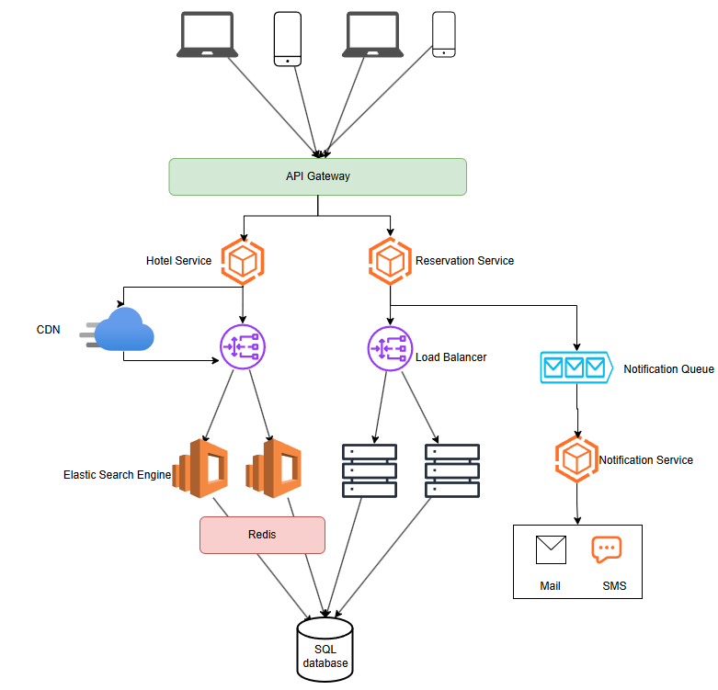

Can use DNS if required to scale globally
- Cache: Inventory & hotel details via Redis
- CDN: Serve hotel images and static content (JS/CSS) globally
- Message Queue (e.g., Kafka/RabbitMQ) for async tasks: notification dispatch, analytics processing, inventory sync with channels

7. Miscellaneous

1. What if payment fails after reservation?
Approach: Temporary Lock with Expiry
- When the user starts checkout, lock the room in a temporary way (e.g., in Redis or DB with status = “pending”)
- Set a timeout (e.g., 10–15 mins)
- If payment is not received within timeout:
  - Cancel booking
  - Unlock inventory (room becomes bookable again)

If a payment fails after reserving a room, we mark that reservation as temporary and set an expiry. If the user doesn’t pay in time, the system automatically cancels the reservation and makes the room available again.

2. How prevent double booking?
Preventing double booking means making sure two users can’t book the same room for the same dates at the same time. Here's a simple explanation of how to do it:

Technique | Explanation
Database Locking | Use SELECT FOR UPDATE in SQL to lock the row while booking. Only one booking can proceed.
Optimistic Locking | Check the version of the room row; if someone updated it during your booking, abort your booking.
Redis Lock | Place a temporary lock (e.g. room_123_booked = true) with TTL (like 10 mins). If lock exists, no one else can book.

3. How support global users & latency?
To support global users and ensure low latency, we need to bring data and services closer to users and optimize every layer of the system. Here's a simple explanation:
1. Use CDN (Content Delivery Network)
- Serve static assets (hotel images, JS/CSS, etc.) from edge servers near the user
- Reduces load time drastically
- Example: Cloudflare, Akamai

2. Deploy Servers in Multiple Regions
- Use regional data centers (e.g., AWS in US, EU, Asia)
- Handle requests in the nearest location, reducing round-trip time

3. Geo-Based Load Balancer
- Detects the user’s location
- Routes traffic to the nearest backend/server region
- Ensures faster response times

4. Sharded/Replicated Databases
- Sharding by region (e.g., Europe data in EU DB, US data in US DB)
- Read replicas in different regions for fast read access
- Ensures fast search/bookings from anywhere

5. Asynchronous Operations
- Use message queues for non-critical operations (emails, analytics)
- Keeps the user-facing flow fast and smooth

